Devops Final Test

1) Branching Strategy

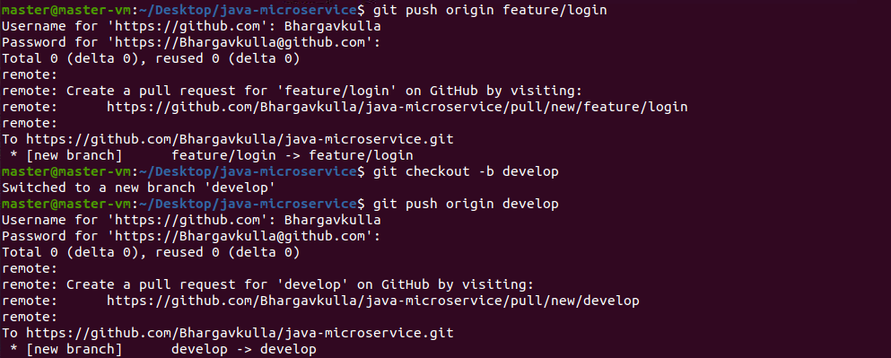

2) Building and testing the Java application using Maven

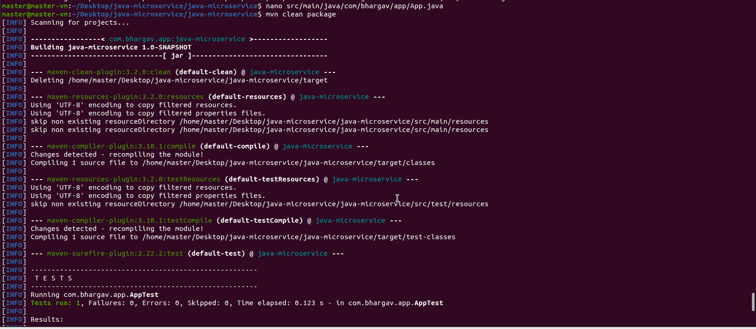

3)Building Dockerfile

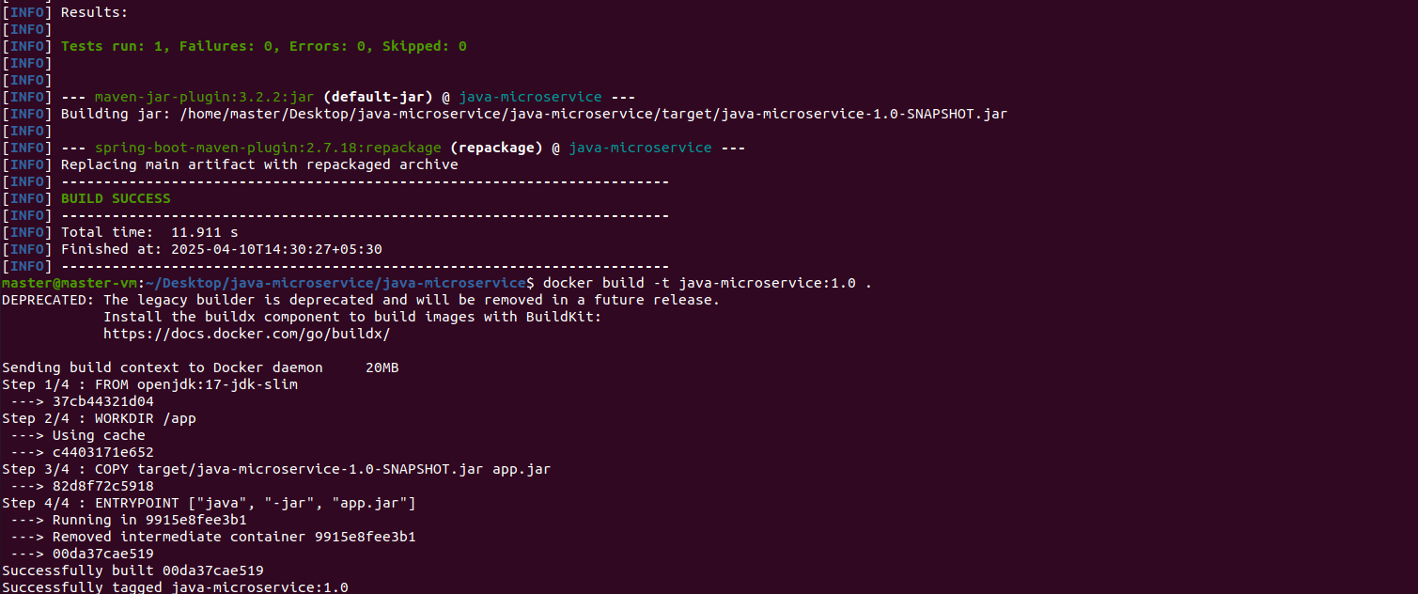

Checking localhost:9090 through terminal



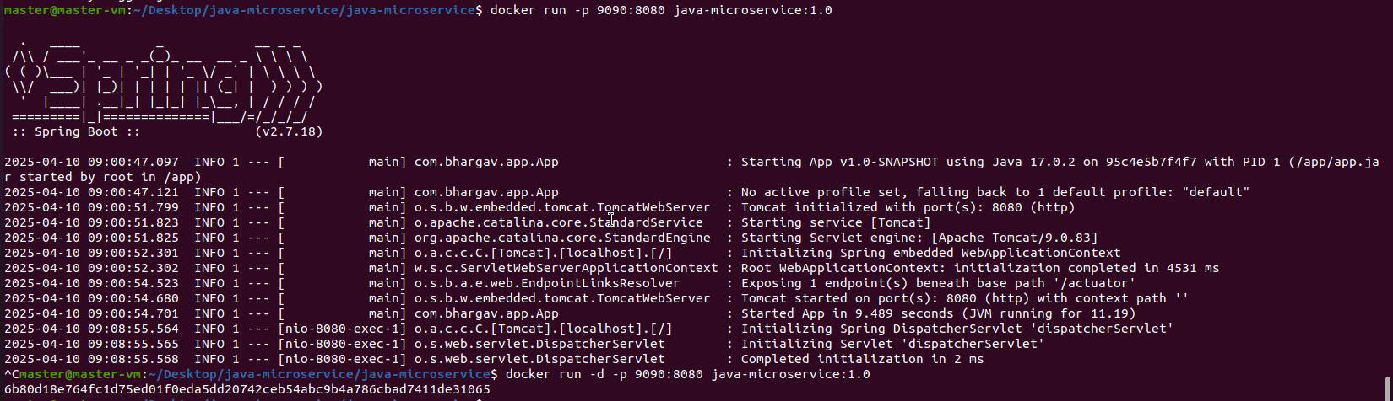

Checking localhost:9090 through Web Browser

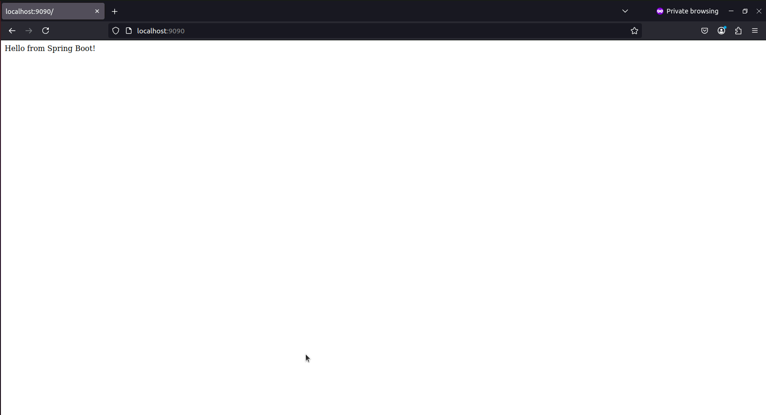

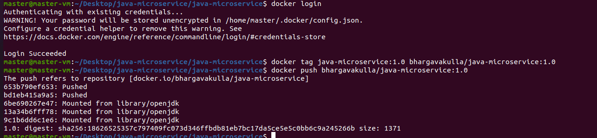

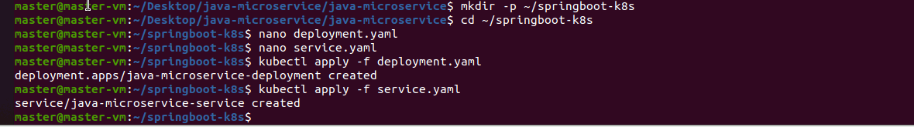

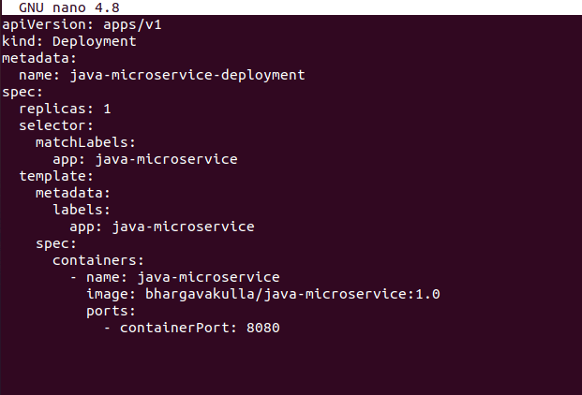

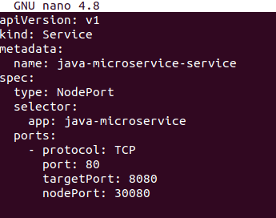

Checking worker1 through web server

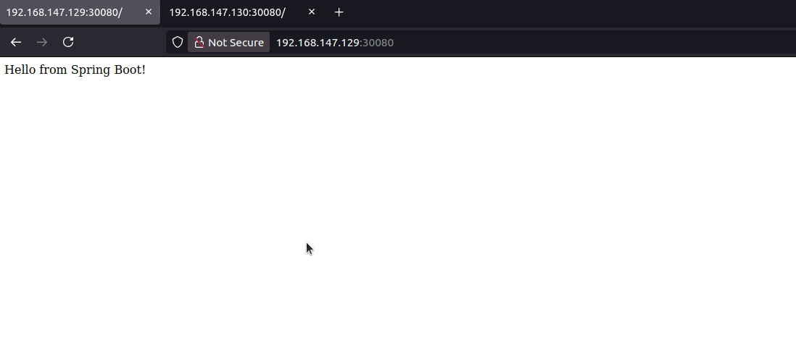

Checking Worker 2 through Web Server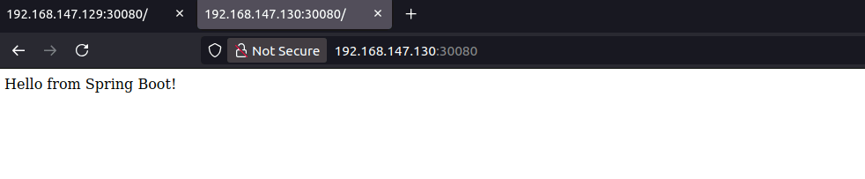

4) Kubernetes Deployment



Checking all pods are running or not



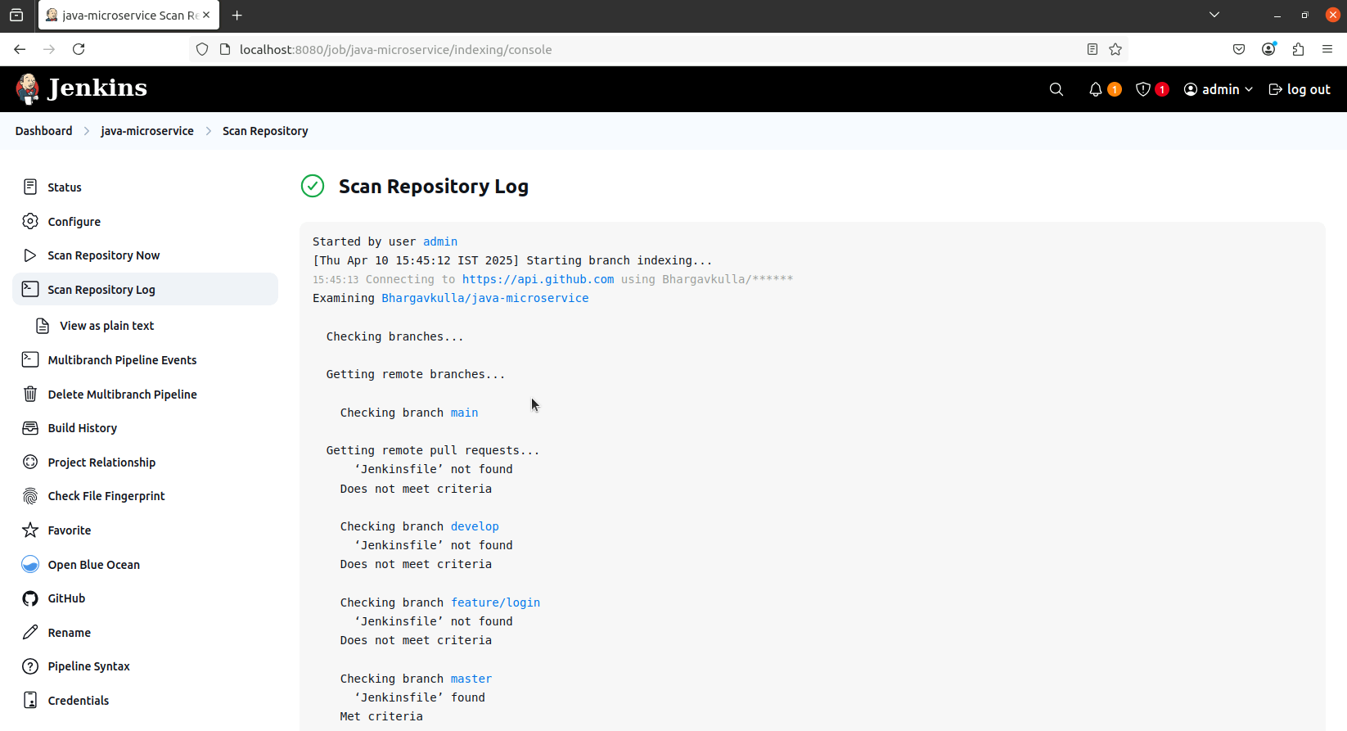

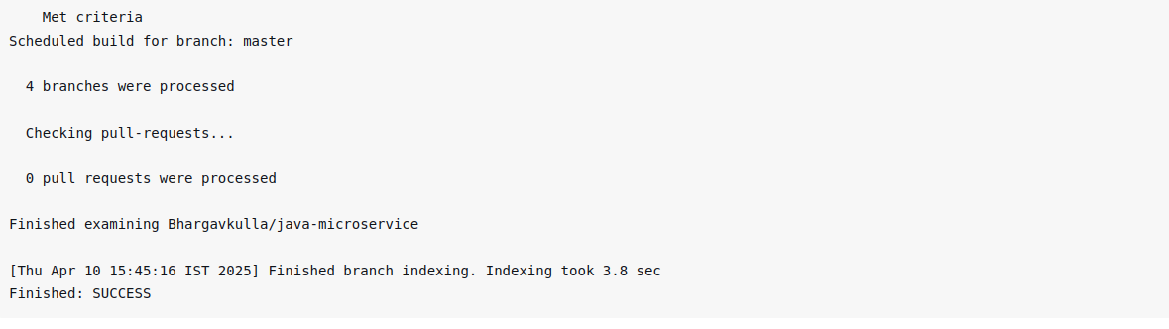

Created Webhook

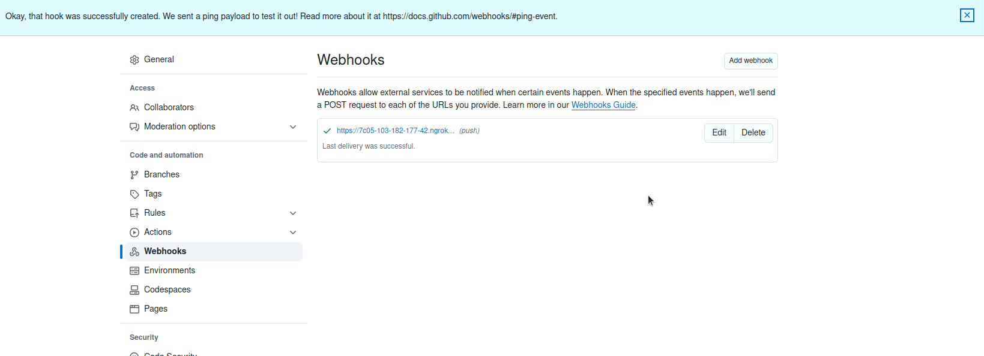Final Output

